A Comparative Analysis of Inference Mechanisms Applied to Solving the Rush Hour Board Game.

Daniel Boden  School of Computing  Teesside University  P4048818@tees.ac.uk | Dean Duff  School of Computing  Teesside University  P4261930@tees.ac.uk | Jo Humphreys  School of Computing  Teesside University  P4048801@tees.ac.uk

Keywords: COM3036-N-BF1-2017 A Comparative Analysis of Inference Mechanisms Applied to Solving the Rush Hour Board Game.
Abstract
This paper investigates a comparative analysis of A-Star (hereafter referred to as A*) and planner inference mechanisms, in providing solutions to solving the board game Rush Hour. Papers such and Comparative Study of Different Algorithms to Solve N Queens Problem (Mukherjee, Datta, Chanda & Pathak, 2015) and A Comparative Study of Three Heuristic Functions Used to Solve the 8-Puzzle (Iordan, 2016) have similarly provided analysis of other types of sliding puzzles and board games. Discovering which inference mechanism provides the “best” solution, will involve analysing multiple factors of the solutions provided, such as speed, cost, and efficiency. To facilitate the investigation, Clojure implementations of the A* and planner inference mechanisms will be found and extended upon where necessary, and the world state representing the Rush Hour game board will be designed and implemented using tuples within a Clojure environment through which inference mechanisms will interact with and modify, using operators dependent on conditions satisfied by the puzzle’s current state. Extending upon the experiment tools and environment, a NetLogo based model will also be built to provide a visual display of the puzzle’s environment with which the Clojure inference mechanism will then interact using sockets to pass commands to the model. The NetLogo model will thus provide a visual representation of each step of the solutions found, and can help expand upon the analysis performed on said solutions.
1. Introduction & Background
The Rush Hour board game was created by Nobuyuki “Nob” Yoshigahara, and is a puzzle based game following the theme of an overcrowded car park, in which players move vehicle pieces on the board to allow the target vehicle to reach the exit. The rules of the game are rather simple, vehicles placed onto a n x n grid can move either vertically both north and south, or horizontally east and west. The orientation of the vehicles, which are at a minimum of two grids spaces in length, determine the directions that the vehicle can move (relatively forward and reverse). However, vehicles can only move in those directions if they are not obstructed by either another vehicle or the walls of the map. For the puzzle to be successfully solved, the player’s vehicle must successfully reach the exit of the car park. As the puzzle space is populated with many obstacles, such as other vehicles, as well as any immovable objects implemented in variants of the game, the player will need to clear a path to the exit through which the target vehicle can traverse. Variables such as the number of vehicles, their position on the board, and the distance of the target vehicle from the exit all serve as factors which can affect difficulty of the puzzle. Although on the surface the puzzle may appear rather simplistic in its approach, there are complexities involved which make this puzzle an ideal candidate for testing a number of inference mechanisms, and to analyse the approach and methods of successfully solving the puzzle.
A* and planner inference mechanisms will be used to find solutions to the game, as well as a variation of the A* search algorithm, which implements a cost base of zero, subsequently achieving the same effect as a breadth-first search, which would be used as a worst-case scenario method of finding a solution to a puzzle. The reasoning behind the choice of algorithms used to find a solution is that they both have different methods of approach to reach a solution. The A* algorithm takes a cost-based approach to solving the problem and will return the most cost-efficient solution to reaching the goal. In respect to the puzzle, the A* algorithm will clear a path towards the goal by moving obstructions, each movement adding to the total cost of the solution. For example, if an obstruction were to be cleared in order to allow the target car a single move, and that could be achieved by either moving a single non-player car to clear the way, or shifting multiple non-player vehicles to achieve the same result. The cost would be greater for the node which executes the greater number of moves. The planner approaches the problem in an entirely different manner, by starting from a goal and working backward to reach the start state.
The key focus will be to compare and contrast the efficiency of the different methods in achieving the solution to the puzzle under various scenarios. The experimental scenarios will set up in such a way to demonstrate the differences between the different mechanisms. This will help in identifying the most efficient method of solving this type of puzzle.
2. Our Work
2.1. NetLogo
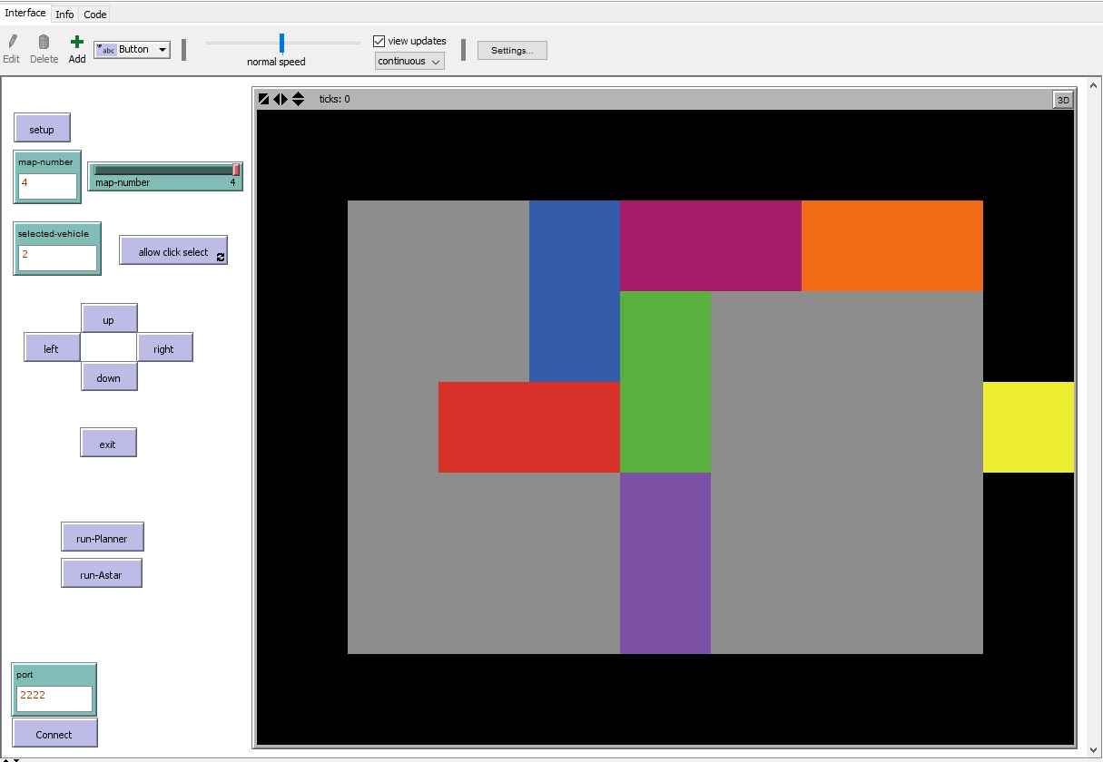
Fig 1. An image of the NetLogo model, depicting the game board in its initial world state.
A NetLogo model has been designed in which the “board” represents a grid of 9 patches by 7 patches. However, the playable space within which the vehicles can move has been restricted to 7 by 5, as the model includes to a black wall that surround the grey ‘Car park’, the exception being the single yellow exit at the rightmost edge of the board. Vehicles were the only objects that varied between each map, a map representing different layouts of vehicles across the car park. The map size and the exit location, however, remained consistent across all available maps.

;players car
ask patch 2 3 [
set pcolor red
set vehicleNumber 1
set isvehiclefront true
set axis "x"
set axis-value 3
]
ask patch 1 3 [
set pcolor red
set vehicleNumber 1
set isvehiclefront false
set axis "x"
set axis-value 3
]

The above code snippet shows an individual vehicle represented in the NetLogo model. Two patches are given a specific colour to represent the presence of a vehicle at that location. The patches have a variable of vehicleNumber, set to the same value to allow for easier selection of the ‘vehicle’ in the move procedures. The property isvehiclefront exists to help with moving vehicles and ensuring that a move is legal within the rules of the game. Finally, the axis and axis-value are used by the move procedures to determine whether the vehicle must move vertically or horizontally, ‘x’ represents a vehicle that can move along the x-axis (horizontally) while ‘y’ can move along the y-axis (vertically). To reduce the variables on the patches and simplify the move procedures, the vehicle with a vehicleNumber of ‘1’ was always used to represent the ‘target’ vehicle trying to exit the car park.
2.2. Room/Map setup
To introduce complexity into the problem, various puzzle spaces were implemented, ranging from a simple 2 vehicle puzzle, in which very few moves are required to reach a goal state. To a more complex state involving multiple vehicles, wherein vehicles were placed around the board in a configuration that resulted in other non-player vehicles being completely obstructed by other vehicles, which would then have a knock-on effect to other vehicles. This made the task of exiting the car park more difficult and introduced a larger amount of possible legal moves available. In addition, it also allows the search algorithms to be run on a problem which would produce few move possibilities, which would drastically reduce the amount of time and moves taken to reach a goal state. This is useful for testing the algorithms and ensuring that the goal state has been reached as expected in a timely manner.
Initially, the problems were solved manually using an online version of the Rush Hour game. This was required to ensure that the problem spaces, which the algorithms would attempt to solve, would be able to achieve a goal state. As mentioned the first problem space which was implemented involved 2 vehicles. A 7 by 9 patch grid was provided to the algorithms (Fig 2.) with the player car lined up with the exit patch, with a non-player vehicle obstructing the player vehicle’s path. With this setup there would only be a few possible states within which could be achieved, both of which would clear the obstruction to the player vehicle, subsequently allowing the player vehicle to reach the goal.
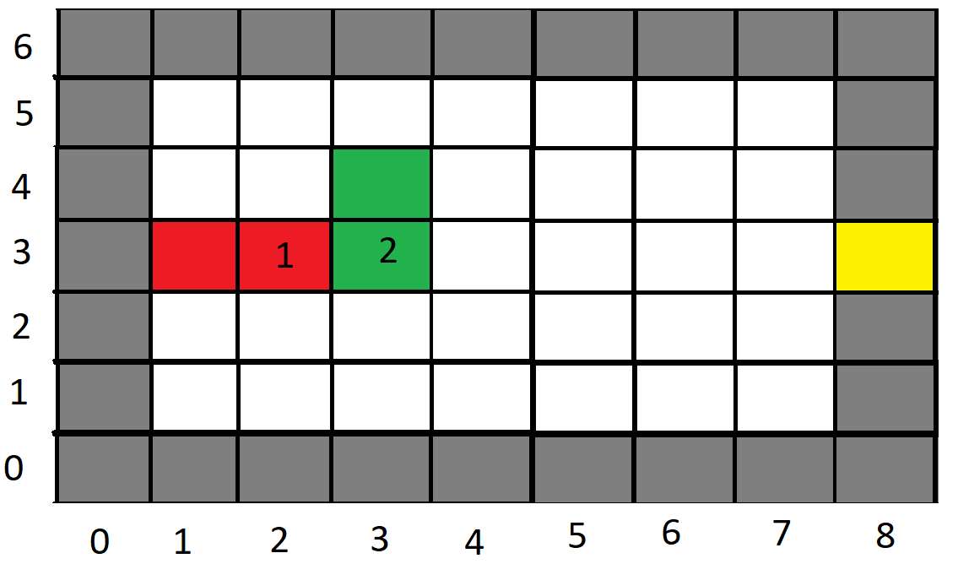
Fig 2. Example of the simple puzzle space described above.

To increase complexity in the puzzle space more cars were added, each laid out various directions. This new puzzle used the same sized 7 by 9 board, allowing for additional scenarios such as one that allowed the goal state to be reached by granting the other non-player vehicles freedom to move in both their available directions and thus provided multiple possible solutions from the same layout, as demonstrated in Fig 3. To achieve the goal state, it requires non-player vehicle 2 and 3 to be moved vertically to clear the path. For this vertical movement to be possible it requires the horizontal movement of non-player cars 4 and 5 out of their path..
An interesting fact of this scenario is that all of the non-player cars can ultimately move to the extreme edges of the map in either directions, providing more than one clear solution to the problem. Potentially, each inference mechanism employed could find a unique solution. Once all the results and moves made for each respective algorithm are returned, it would be possible to analyse on how each algorithm successfully solved the puzzle. For example, vehicle 5 can be moved to the far east or far west of the car park, allowing both vehicles 2 and 3 to move into the now free space, subsequently clearing a path of the player vehicle to reach the goal. Alternatively, each of the horizontal non-player vehicles could move a single patch out of the path of the adjacent vertical vehicles, which would, in turn, allow the vertical cars to each move into the space created by the aforementioned vehicles, clearing a path for the player vehicle to reach the exit.
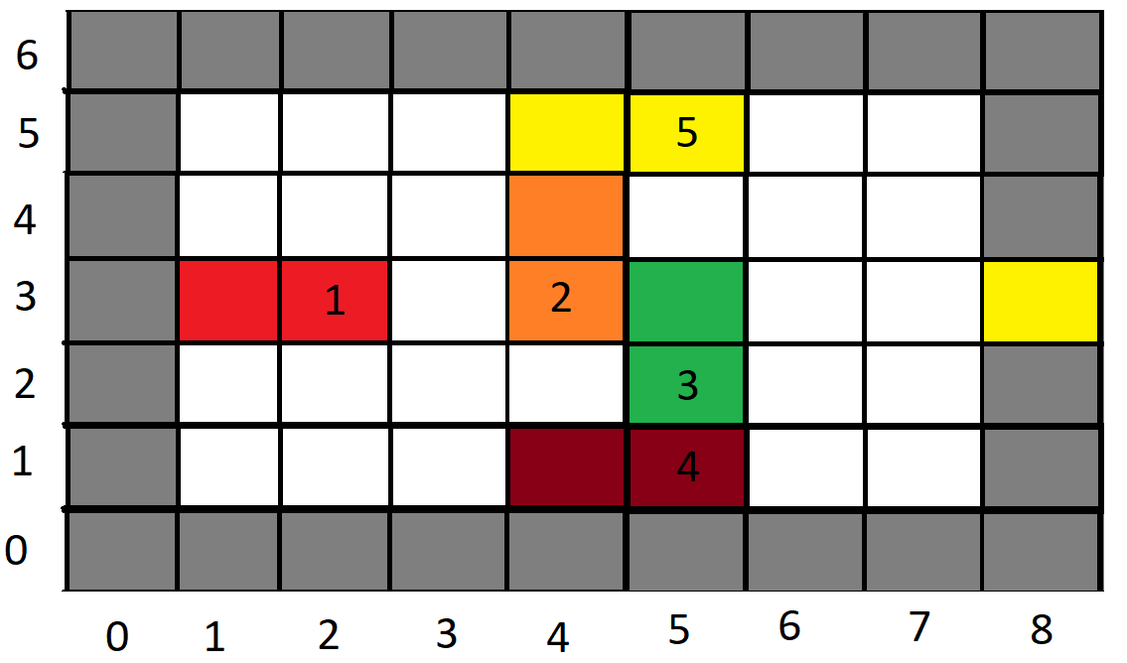
Fig 3. Example of a board layout in which the puzzle can be solved in a number of equally valid ways.
To further increase the complexity of the puzzle, additional puzzles were implemented which would require movement of the player car in more than one direction, as demonstrated in Fig 4. This would increase the complexity by making it necessary for the player car to move incrementally in both directions in order to clear spaces for non-player vehicles that may themselves be causing obstructions to be cleared in order to solve the puzzle. Again, this could achieve some interesting results as the player vehicle may need to move away from the goal, an action that may immediately appear counterproductive to reaching the goal. As well as making the puzzle more complex in some cases, as the player car could move away from the goal state and subsequently block any further movement. This would greatly increase the number of non-player movements required as the additional move would be required whenever this may occur. It would be interesting to see how each inference mechanism would deal with the back-tracking element of such a puzzle.
The puzzle space (Fig 4.) demonstrates a situation in which backtracking would be necessary, since there are no possible moves available for non-player vehicles otherwise. The non-player vehicle 3 is blocking the path for the player vehicle, but the vehicle is itself blocked in both directions, by vehicles 2 and 5. The first move required to achieve movement towards the goal would be for vehicle 1 (the player vehicle) the move away from the goal, which in turn would allow the movement vehicle 4, thus paving the way further legal moves for the remaining non-player vehicles.
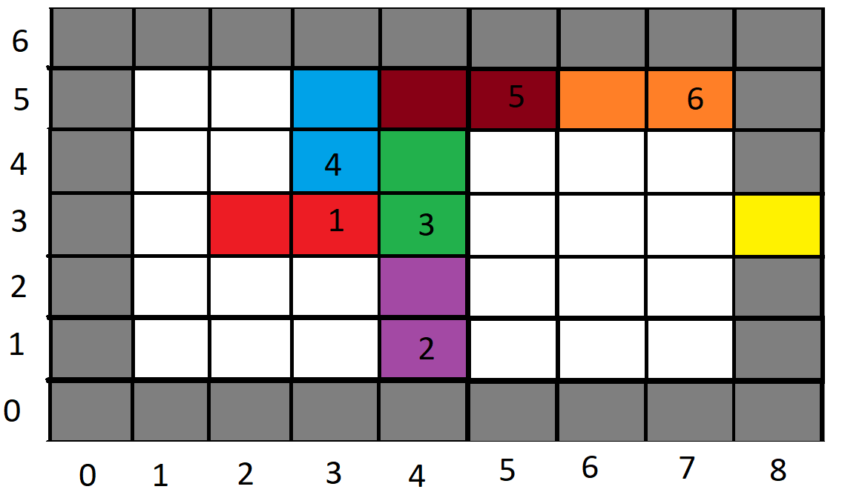
Fig 4. Example of the puzzle space where backtracking is required.
To allow the inference mechanisms to find a solution to each of the problems, the puzzle spaces would require mapping into tuples. These tuples would represent a world state which would mirror that of the puzzle spaces used to identify the different scenarios outlined above. To achieve the correct representation of the world space, the tuples would implement a wall surrounding the world space as demonstrated by the grey areas surrounding the grid in Figure 4. One of these patches would be used as a goal patch. This enforces an area that no vehicles in the puzzle can enter, with the express exception of the exit patch, into which the player vehicle can enter, resulting in a goal state.
Tuples are defined in Clojure by mapping a 1:1 copy of the puzzle spaces, by first defining the size of the puzzle space which is being solved. Then assigning all the patches within the space a definition, for example, walled patches, vehicles, and goal patches. The below snippet of Clojure code is an example of the representation of a puzzle space as a tuple. Which shows that the world state uses a 7 by 5 grid of patches, followed by the assignment of patches used for walled areas, as well as free spaces that vehicles can move into.

(list 'max-size 7 5)
;;y 0 wall
;(list 'at 0 0 'none)
;(list 'at 1 0 'none)
;(list 'at 2 0 'none)
;(list 'at 3 0 'none)
;(list 'at 4 0 'none)
;(list 'at 5 0 'none)
;(list 'at 6 0 'none)
;(list 'at 7 0 'none)
;(list 'at 8 0 'none)
;;y 1
;(list 'at 0 1 'none) wall

Next would be the task of assigning patches representing vehicles and the exit patch. This is achieved similarly to assigning walled areas and free space, but instead the vehicles orientation, colour, and type of patch. By doing so eliminates any illegal movement of vehicles, as when an orientation is defined, it forces the vehicle to move solely along a single axis. The goal patch is defined as a single patch, this is required for defining the completion of the puzzle. As the player vehicle needs to reach this patch for a puzzle to be solved. Below is another snippet of code, which demonstrates the implementation of a goal patch, as well as the player vehicle with all its properties assigned.

;;goal
(list 'isa 8 3 'goal)

;;player vehicle
(list 'isa 'pv 'vehicle)
(list 'colour 'pv 'red)
(list 'orientation 'pv 'horiz)
(list 'at 3 3 'pv)
(list 'at 2 3 'pv)
(list 'clear-me 2 3 'pv)
2.3. Inference Mechanisms
For this model, the use of three inference mechanisms were employed in an attempt to compare each one’s efficiency in a number of aspects. Each mechanism depends on a collection of possible actions and their rules, defining the necessary requirements for execution and the constraints by which they can modify the model. For the purposes of this paper, existing Clojure-based implementations — or adaptations of those implementations — of the following algorithms were acquired from the website Agent Domain (https://agent-domain.org)
As an example, an east or west facing car positioned at grid co-ordinates (3, 2) can only move to the adjacent grid co-ordinate (4, 2) if that sector is actually clear. This would be reflected in a an action called move-x with a precondition set that expects (at 4 2 none). This is, of course, a somewhat simplified example, as ultimately the model would provide a level of complexity for which additional preconditions would be required, such as checking whether a co-ordinate is actually adjacent. Failure to consider these additional restraints would likely result in a car somehow teleporting across the map to the first sector it finds.
An example of the operators used in the algorithms employed can be found
below:
:move-horiz
{:name move-horiz
:when (
(at ?vx1 ?y ?v)
(at ?vx2 ?y ?v)
(isa ?v vehicle)
(at ?nx ?y none)
(:guard (= 1
(abs (- (? vx1) (? vx2)))
(abs (- (?nx) (? vx1))))))
:add {:state ((at ?nx ?y ?v)
(at ?vx2 ?y none))}
:del {:state ((at ?nx ?y none)
(at ?vx2 ?y ?v))}
:cmd ((move ?v to ?nx ?y))
:txt ((?v moves to ?nx ?y))
:cost 1
}

The :when property of the operator defines the preconditions required for this operator to be employed, with the parts preceded by a question mark substituted with qualifying values using a pattern matcher (an implementation of which has also been obtained from Agent Domain). The :guard property serves to apply additional constraints that don’t exist directly within the world state but instead must be calculated.
Upon executing an operator, the contents of the :del property, also filled in by the pattern matcher, are removed from the world state and replaced by the contents of the :add property.
The :cmd property provides an additional sequence of commands to be passed into another function or even language. In this case the contents of this property would be eventually passed into the NetLogo model that visually represents the world state, executing functions that would manipulate that visible model. The :txt property, for the most part, serves to provide a textual description of the property that has been executed, usually one that would be easy for a human reader to understand to some degree.
2.4. Breadth-first
A breadth-first search mechanism, quite simply, iterates through the various branches of the tree of potential decisions that can be made on the path toward devising a solution. While it remains likely that a breadth-first search could find the most efficient solution, this will, unfortunately, take some time to complete. Potentially, anything from a few minutes to a few hours, depending on the size of the world state, the available operators and the potential branches at each step, of which the search would be traversing every possible branch encountered In addition, expanding the world state by even the smallest amount can serve to expand that tree significantly.
2.5. A* (A-star)
A*, or A-star, operates similarly to breadth-first searches, with a key difference in that an additional critera for execution is the cost of each operator, the lowest-costing action being the one that is attempted first. This cost, however, depends on the requirements of the model itself, and assigning a cost to an action could either be arbitrary or, if the developer is feeling brave, have the cost calculate itself with a formula that takes advantage of a number of factors. An example of such a formula could include heuristics such as Hamming Distance (the number of incorrectly-placed objects based on the intended goal state), or Manhattan Distance (the number to “steps” an object must make in order to reach its destination).1
A collection of operators with suitably defined costs or formulae can potentially find the most efficient path to a solution. However, the efficiency of that path isn’t always guaranteed.
At the time of writing, the operators developed for this model did not include such formulae for its cost, as time constraints forced the mere implementation of arbitrary 1 or 2 as costs for horizontal movement and vertical movement, respectively.
2.6. Goal-based planner
A goal-based planner works similarly to a breadth-first search or A*, however, there exists a key difference in that this inference mechanism begins from a goal state and works its way backwards. As such, an additional few sets of rules are required for each operator to assist and constrain this reverse search. However, if and when the planner succeeds in finding a path, then all that is required for the planner to do is perform each action in the resulting stack.
Developing the ops for a goal-based planner can be extremely difficult, as the goal state it works with is only partial (that is to say, it only contains the actual conditions required for a world state to qualify as a goal state, with none of the remaining world state included), and can thus only take the original state into account at all times, or until it reaches a point at which it can work through the stack and complete some operators. In addition, the developer desigining the operators must learn to work backwards with these restrictions in account. This can be alleivated somewhat by including operators that mark targets as “protected”, but this still requires determining what needs protecting and when.

An example of an operator with the aforementioned additional rules can be seen
below:
:move-horiz
{
:name move-horiz
:achieves (at ?x ?y ?v)
:when (
(at ?x ?y none)
(at ?nx1 ?y ?_)
(at ?nx2 ?y ?_)
(at ?vx1 ?y ?v)
(at ?vx2 ?y ?v)
(clear-me ?vx ?y ?v)
(isa ?v vehicle)
(:guard (and
(not= (? x) (? nx1) (? nx2))
(= 1
(abs (- (? nx1) (? nx2)))
(abs (- (? x) (? nx1)))
(abs (- (? vx1) (? vx2))))
(or (= (? vx1) (? vx))
(= (? vx2) (? vx)))
(> (abs (- (? x) (? nx2)))
(abs (- (? x) (? nx1))))
(> (abs (- (? x) (? vx1)))
(abs (- (? nx1) (? vx1)))))))
:post (
(protected ?x ?y ?v)
(at ?nx1 ?y ?v)
)
:pre (
(at ?nx1 ?y ?v)
(at ?x ?y none)
(protected ?x ?y ?v)
)
:del (
(at ?nx2 ?y ?v)
(at ?x ?y none)
)
:add (
(at ?x ?y ?v)
(at ?nx2 ?y none)
)
:cmd ((move ?v ?x ?y))
:txt ((?v moves to ?x ?y))
}
In this case, :when has become the preconditions for adding this operation to the stack that would eventually be executed in the correct sequence, with the preconditions for actually executing the operation now under the :pre property.
An additional property, :post adds some postconditions for prior steps in the stack to achieve, which will be compared with the :achieves property as a means of more quickly determining operators to consider. All other properties work in the exact same manner as their A* counterparts.

Of additional note is the concept of “protecting” items in the world state. In this case, protection serves to establish where a vehicle should exist by that point, and as such serve as a guiding precondition. An example of the operator for protecting a position can be seen below.
:protect
{
:name protect
:achieves (protected ?x ?y ?v)
:add ((protected ?x ?y ?v))
}
3. Results
3.1. A* experiments
The A* experiments were executed within a lein repl using the following command:
(time (pprint (A*search {:state test-world1 :cost 0} (fn [x] (contains? x '(at 8 3 pv))) lmg)))
‘test-world1’ was replaced with the number of the map to be tested before the execution of the command. The cost used for the A* experiments was a simple cost of 2 for vertical moves and a cost of 1 for horizontal moves, the idea behind this cost design was due to how the player car can only move horizontally towards the exit not vertically, thereby making it so that moving the player car towards the exit was prioritized to an extent.

Solutions created:

Map 1
:txt ((npv2 moves to 3 5))
:txt ((pv moves to 3 3))
:txt ((pv moves to 4 3))
:txt ((pv moves to 5 3))
:txt ((pv moves to 6 3))
:txt ((pv moves to 7 3))
:txt ((pv moves to 8 3))

Map 2
((npv4 moves to 3 1))
((npv3 moves to 5 1))
((npv5 moves to 6 5))
((npv2 moves to 4 5))
((pv moves to 3 3))
((pv moves to 4 3))
((pv moves to 5 3))
((pv moves to 6 3))
((pv moves to 7 3))
((pv moves to 8 3))

Map 3
:txt ((pv moves to 1 3))
:txt ((npv4 moves to 3 3))
:txt ((npv5 moves to 3 5))
:txt ((npv5 moves to 2 5))
:txt ((npv3 moves to 4 5))
:txt ((npv5 moves to 1 5))
:txt ((npv4 moves to 3 5))
:txt ((pv moves to 3 3))
:txt ((pv moves to 4 3))
:txt ((pv moves to 5 3))
:txt ((pv moves to 6 3))
:txt ((pv moves to 7 3))
:txt ((pv moves to 8 3))

Compiled Results:

Map | Moves Made | Test1 (seconds) | Test2 (seconds) | Test3 (seconds) | Test4 (seconds) | Test5 (seconds) | Average time taken (seconds)
1 | 7 | 1.41 | 1.04 | 0.98 | 0.94 | 1.02 | 1.08
2 | 10 | 457.46 | 1038.58 | 1550.48 | 313.26 | 684.68 | 808.89
3 | 13 | 11.13 | 13.22 | 15.69 | 18.38 | 21.5 | 15.99

Notes:
- Each run of the A* algorithm used up around 35% of the CPU of the test machine and 2.5 – 3GB of ram while executing.
Review:
The A* algorithm tests ran against the maps shown in figures 2-4, ran with few problems, the time taken for the simple map 1 and the back-tracking map 3 were both reasonably fast and produced solutions that were within our expectations. A considerable amount of time however was spent on solving map 2, which was not expected. All solutions produced found the shortest possible route for all the maps, and the movements made in them solutions looked reasonably well structured and logical, with no unnecessary or inefficient moves made.
From looking further into what the cause of the exponential increase of the time taken in experiments performed for map 2, it can be assumed that both the loose placement of the vehicles on the map causing multiple valid solutions to be possible and the poor cost implementation for the A* algorithm could be the cause.

3.2. Breadth First experiments
The Breadth First experiments were executed within a lein repl using the following command:
(time (pprint (A*search {:state test-world1 :cost 0} (fn [x] (contains? x '(at 8 3 pv))) lmg)))
‘test-world1’ was replaced with the number of the map to be tested before the execution of the command. Due to the A* search algorithm being an extension of a simple Breadth First search algorithm with cost implemented, to run tests with a Breadth First algorithm the costs for all moves was set to 1, thereby nullifying the impact of cost.

Solutions created:

Map 1
:txt ((npv2 moves to 3 5))
:txt ((pv moves to 3 3))
:txt ((pv moves to 4 3))
:txt ((pv moves to 5 3))
:txt ((pv moves to 6 3))
:txt ((pv moves to 7 3))
:txt ((pv moves to 8 3))

Map 2
:txt ((pv moves to 3 3))
:txt ((npv4 moves to 3 1))
:txt ((npv5 moves to 6 5))
:txt ((npv3 moves to 5 1))
:txt ((npv2 moves to 4 5))
:txt ((pv moves to 4 3))
:txt ((pv moves to 5 3))
:txt ((pv moves to 6 3))
:txt ((pv moves to 7 3))
:txt ((pv moves to 8 3))

Map 3
:txt ((pv moves to 1 3))
:txt ((npv4 moves to 3 3))
:txt ((npv5 moves to 3 5))
:txt ((npv5 moves to 2 5))
:txt ((npv5 moves to 1 5))
:txt ((npv3 moves to 4 5))
:txt ((npv4 moves to 3 5))
:txt ((pv moves to 3 3))
:txt ((pv moves to 4 3))
:txt ((pv moves to 5 3))
:txt ((pv moves to 6 3))
:txt ((pv moves to 7 3))
:txt ((pv moves to 8 3))

Compiled Results:

Map | Moves Made | Test1 (seconds) | Test2 (seconds) | Test3 (seconds) | Test4 (seconds) | Test5 (seconds) | Average time taken (seconds)
1 | 7 | 2.91 | 2.35 | 2.26 | 2.29 | 2.39 | 2.44
2 | 10 | 1480.06 | 2487.92 | 752.68 | 1935.65 | 1037.7 | 1538.8
3 | 13 | 26.84 | 37.48 | 49.97 | 62.83 | 71.91 | 49.81

Notes:
- Each run of the Breadth First algorithm used up around 40% of the CPU of the test machine and 3.5 – 4GB of ram while executing.

Review:
The Breadth First modification to the A* algorithm, ran all the tests without any errors or problems, however the time taken for tests on map 3 and especially map 2 were very long, with an average time of 25 minutes for the algorithm to complete a solution to map 2. As stated in the notes section of the Breadth First tests, the ram usage for the tests climbed up to and above 4GB’s, for some of them test. Again, however all solutions produced found the move efficient number of moves for the selected maps, and the steps produced appear to be logical and without any unnecessary/wasted movements.

3.3. Planner experiments
The planner experiments were executed within a lein repl using the following command:
(time (pprint (:txt (planner test-world1 (list 'at 8 3 'pv) primary-ops))))
‘test-world1’ was replaced with the number of the map to be tested before the execution of the command.

Solutions created:

Map 1
((npv2 moves to 3 5)
(pv moves to 3 3)
(pv moves to 4 3)
(pv moves to 5 3)
(pv moves to 6 3)
(pv moves to 7 3)
(pv moves to 8 3))

Map 2
((npv5 moves to 6 5)
(npv5 moves to 7 5)
(npv3 moves to 5 4)
(npv3 moves to 5 5)
(npv2 moves to 4 5)
(pv moves to 3 3)
(pv moves to 4 3)
(pv moves to 5 3)
(pv moves to 6 3)
(pv moves to 7 3)
(pv moves to 8 3))

Map 3 FAIL
(:dbg GOALS:)
(:dbg (at 7 5 npv6))
(:dbg (cleared 7 5 npv6))
(:dbg (at 0 5 npv6))
(:dbg (cleared 7 5 npv6))
(:dbg (at 7 5 npv5))
(:dbg [branch-horiz :=> (at 7 5 npv5)])
(:dbg [branch-horiz :=> (at 7 5 npv5)])
(:dbg [branch-horiz :=> (at 7 5 npv5)])
(:dbg [branch-horiz :=> (at 7 5 npv5)])
(:dbg [branch-horiz :=> (at 7 5 npv5)])
(:dbg [branch-horiz :=> (at 7 5 npv5)])
(:dbg [branch-horiz :=> (at 7 5 npv5)])
(:dbg [branch-horiz :=> (at 7 5 npv5)])
(:dbg [branch-horiz :=> (at 7 5 npv5)])
(:dbg [branch-horiz :=> (at 7 5 npv5)])
(:dbg [branch-horiz :=> (at 7 5 npv5)])
(:dbg [branch-horiz :=> (at 7 5 npv5)])
(:dbg [branch-horiz :=> (at 7 5 npv5)])
(:dbg [branch-horiz :=> (at 7 5 npv5)])
(:dbg [branch-horiz :=> (at 7 5 npv5)])
(:dbg [branch-horiz :=> (at 7 5 npv5)])
(:dbg [branch-horiz :=> (at 7 5 npv5)])
(:dbg [branch-horiz :=> (at 7 5 npv5)])
(:dbg [branch-horiz :=> (at 7 5 npv5)])
(:dbg [branch-horiz :=> (at 7 5 npv5)])
(:dbg [branch-horiz :=> (at 7 5 npv5)])
(:dbg (cleared 4 5 npv5))
(:dbg (at 0 5 npv5))
(:dbg (cleared 4 5 npv5))
(:dbg (at 4 5 npv3))
(:dbg [branch-horiz :=> (at 4 5 npv3)])
(:dbg (cleared 4 3 npv3))
(:dbg (at 4 0 npv3))
(:dbg (cleared 4 3 npv3))
(:dbg (at 4 3 pv))
(:dbg [branch-vert :=> (at 4 3 pv)])
(:dbg [move-horiz :=> (at 5 3 pv)])
(:dbg [move-horiz :=> (at 6 3 pv)])
(:dbg [move-horiz :=> (at 7 3 pv)])
(:dbg [move-horiz :=> (at 8 3 pv)])
(:dbg ------)

Compiled Results:

Map | Moves Made | Test1 (seconds) | Test2 (seconds) | Test3 (seconds) | Test4 (seconds) | Test5 (seconds) | Average time taken (seconds)
1 | 7 | 2.24 | 2.87 | 2.23 | 2.18 | 2.09 | 2.32
2 | 11 | 3.25 | 3.34 | 3.48 | 3.54 | 3.81 | 3.48
3 | N/A | N/A | N/A | N/A | N/A | N/A | N/A

Notes:
- Map 3 failed to run and hit a Runtime Exception, in which a limit was breached while searching for a solution, the code snippet for map 3 is from a latter section of the pretty printed command. It shows a problem solving the movement of npv5 (non-player vehicle) seems to have been the cause of the error.
- Each run of the Planner algorithm used up around 40-47% of the CPU of the test machine and 2GB’s of ram while executing.

Review:
The Planner algorithm tests executed in under 3.5 seconds for most tests, but some problems occurred during back-tracking map 3 tests that prevented data from being recorded from the tests, and for the very open and multiple viable solutions map 2, inefficient moves were made. The map 3 error that occurred can be understood from the snippet of code provided showing an instance of the goal stack near the latter end of the algorithm before it threw an exception, in which vehicle 5 was targeted as needing to be moved so vehicle 3 could move, but vehicle 4 was not seen as a vehicle that should/could be moved making it so that no solution for moving vehicle 5 could be found leading to a runtime exception.
Finally, the inefficient movement can be seen in map 2’s solution, were vehicle 5 is moved all the way to the top right of the map, for the vehicles 2 and 3 to then move upwards to move out of the way of the player vehicle 1. Though this inefficiency is only one move extra than the minimum number of moves, on more complex puzzles this could prove exponentially larger, due to there being no cost for moved made and due to the focus of the planner algorithm being to find a solution not necessarily the most efficient one.
4. Analysis & Conclusion
4.1. Analysis
From the analysis performed upon the compiled and raw results of the three algorithms, it appears no clear algorithm performs the tests without some serious problems/flaws. The Breadth first algorithm is as expected the most time consuming of all the algorithms with an average time of 25 minutes to complete is most problematic test, which was map 2. The A* algorithm performed better than the breadth first algorithm by completing most of its tests nearly 50% faster than the Breadth First algorithm, map 2 for example only took 13 minutes on average to complete. The A* algorithm however still took longer than expected to complete the map 2 and map 3 tests, especially the map 2 test, it appeared that the cost implemented in the algorithm help significantly, but as to be expected of a breadth first based algorithm, scaling is its weak point. The Planner algorithm proved to be the fastest algorithm for providing solutions to the map problems, the times taken for most of the maps as previously mentioned were on average under 3.5 seconds. This speed of the Planner algorithm almost made it the unquestionably best algorithm for the Rush Hour puzzle, but multiple flaws prevented it from being a clean-cut answer/solution to the problem. A minor flaw with the algorithm was its lack of focus on finding the most efficient solution to solving a map, as mentioned in the results shown for the solution of map 2, a very curious and slightly inefficient solution was created a solution that wouldn’t be an obvious solution to a human. The major flaw with the planner algorithm however, was its failure to be able to solve map 3, the map designed with back-tracking the player vehicle in mind. It had already been discovered and mentioned that the problem relied on the Planner algorithm calculating how to clear the map from right to left and in doing so when trying to clear vehicle 3 then vehicle 5, vehicle 4 was not considered/seen as a vehicle that required moving.
To summarize, the Breadth first search algorithm will be able to provide solutions to all Rush hour maps that could be created going forward, at an exponentially large cost of time to find said solutions. The A* algorithm similarly to the Breadth First algorithm could also provide solutions to all the potential rush hour maps, with a high chance of the most efficient solutions being found, time taken for finding the solutions however can still have the potential to scale to large numbers even with the algorithm being 50% faster than the Breadth First algorithm. Finally, the planner algorithm in its current state cannot be relied on to be able to provide solutions for any current or future Rush Hour map and cannot, like the Breadth First algorithm, be relied upon to always find an efficient solution. It should be noted however that the speed at which the Planner could solve some of the Rush Hour maps was much faster than any of the other two algorithms, and even upon attempting a map problem that it will fail upon, it will fail fast.
With the information gathered from the experiment results and analysis of the data from the results, it appears the best and most reliable algorithm for solving the Rush Hour puzzle is the A* algorithm. It is the second fastest algorithm for solving the puzzle and though multiple solutions to a Rush Hour puzzle are possible, the solution with the least number of moves is the ‘correct’ solution, thereby making the A* algorithm the most suitable due to its use of cost to find an efficient solution instead of just a solution.
4.2. Conclusion
Although some flaws were found within the Planner algorithm upon executing the experiments, the results and analysis performed on said results for all the algorithms were conclusive and informative and lead to the A* algorithm being chosen as the currently best algorithm for the Rush Hour puzzle. However, both the A* and the Planner algorithms were lacking in certain ways, which may have slightly changed the conclusion reached in the analysis section of the report.
The A* algorithm was implemented with no problems, but the cost implementation used for the algorithm was very simple, potentially too simple and if a more advanced version of a cost was implemented the algorithm could have further decrease in the time required to find solutions.
The Planner algorithm however had many problems, the fact that it didn’t find the most efficient solution was expected due to the nature of how it calculated solutions, but its inability to solve some Rush Hour puzzles was rather disappointing. The speed at which some of the Planner compatible problems were solved was impressive and was one of the strongest values of the algorithm. With the solution finding speed that it has, it could still be used as the first algorithm to run on a Rush Hour puzzle before using the A* algorithm, if the goal is to find a solution fast that isn’t necessarily efficient.
In conclusion, the experiments and tests could be expanded upon, with improved versions of the current algorithms alongside different algorithms that could be used to see if they are an improvement on the A* algorithm.

5. References

Mukherjee, S., Datta, S., Chanda, P., & Pathak, P. (2015). Comparative Study of Different Algorithms to Solve N Queens Problem. International Journal In Foundations Of Computer Science & Technology, 5(2), 15-27.
Iordan, A. (2016). A Comparative Study of Three Heuristic Functions Used to Solve the 8-Puzzle. British Journal Of Mathematics & Computer Science, 16(1), 1-18.
Flake, W, G. Baum, B, E. (2002). Rush Hour is PSPACE-complete, or “Why you should generously tip parking lot attendants”. Elsevier, 270(1), 895-911.
Dhondiyal, D. (2016, May 03). Implementing A-star(A*) to solve N-Puzzle [Blog post]. Retrieved from https://algorithmsinsight.wordpress.com/graph-theory-2/a-star-in-general/implementing-a-star-to-solve-n-puzzle/

